MED D - Specialized Member Services Team (SMST) - Cancellation of Voluntary Disenrollment

Submitting a Cancellation of Disenrollment Request
DISENROL-NEW MCO
NOT ENROLLED
Related Documents

Description: This document provides the Specialized Member Services Team (SMST) with the proper guidance in addressing questions, concerns and issues surrounding a beneficiary’s request to cancel a voluntary disenrollment request.

CCR Process

To submit a request for cancellation of disenrollment prior to the disenrollment effective date, the SMST CCR will:
Step | Action
1 | From the Medicare D Inquiry Tab in PeopleSafe, review the Benefit Effective date and the Benefit Expiration date.  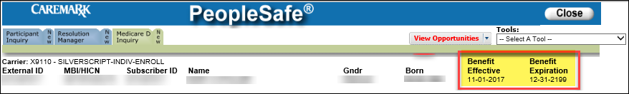
1 | If the cancellation request is received… | Then…
1 | After the Benefit Expiration date | The beneficiary cannot cancel their disenrollment because the disenrollment has already occurred.  Note: The beneficiary will be able to enroll during AEP or if they have a valid Special Election Period (SEP).  - You were disenrolled as of <Benefit Expiration date >. We are unable to cancel your disenrollment. You may submit an enrollment application if you have a valid election period (or during AEP).  - If you would like to remain with our plan, I can transfer you to an enrollment agent now or you can also submit a new application at AetnaMedicare.com.  If a beneficiary states that they were disenrolled in error, this does not mean that an error occurred. It is the CCR’s responsibility to review the disenrollment and proceed accordingly.  Refer to MED D - Specialized Member Services Team (SMST) - PeopleSafe Disenrollment Reason - Processes and References.
1 | After the Benefit Expiration date | If… |  | Then…
1 | After the Benefit Expiration date | Beneficiary wants to speak with an enrollment agent |  | Transfer to an Enrollment Agent. Refer to MED D - Guide to Transferring a Call.
1 | After the Benefit Expiration date | Beneficiary does not want to speak to an agent |  | Close the call:  - Address any benefit issues.  - Document and close the call according to existing policies and procedures, including all options discussed. Refer to the MED D - Call Documentation work instruction.
1 | Before the Benefit Expiration date | Proceed to next step.
2 | From the Medicare D Inquiry - Participant Details tab in PeopleSafe, review the Disenrollment Reason field  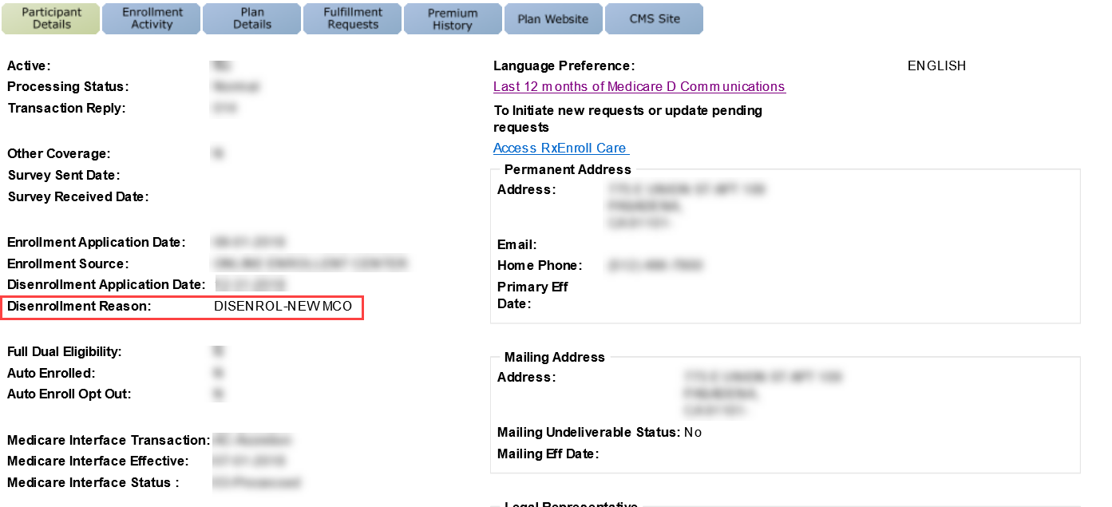
2 | If disenrollment reason is… |  | Then…
2 | DISENROL-NEW MCO |  | Refer to MED D – Disenrollment Due to Enrolling in a Different Prescription Drug Plan (PDP)
2 | Blank (No reason shown) |  | Proceed to Submit an RM Task
2 | Any other reason |  | Refer to MED D - Specialized Member Services Team (SMST) - PeopleSafe Disenrollment Reason - Processes and References

Submitting a Cancellation of Disenrollment Request

Perform the steps below:
Step | Action
1 | Have you already submitted a request to cancel the disenrollment?
1 | If beneficiary says… | Then...
1 | Yes | Review the Medicare D Inquiry tab – View Comments in PeopleSafe to determine if a cancellation of disenrollment request was already submitted.
1 | Yes | If… | Then…
1 | Yes | A task was already submitted | - I can see you have already submitted a cancellation of disenrollment request.  - The request is pending and we cannot submit another request at this time.  Proceed to Step 3.
1 | Yes | No task has been submitted | Proceed to next step.
1 | No | Proceed to next step.
2 | Submit the following RM Task to request a cancellation of disenrollment:  Note: Do not submit a task unless you have verified all steps above.  Task Category: Med D Enrollment - Disenrollment  Task Type: Cancellation of Voluntary Disenrollment  Queue: Med D Enrollment Task  Notes: Document detailed information in the task note such as a phone number for the beneficiary and reason for cancellation.  Do not give out confirmation numbers for tasks to callers. These numbers are not included with the task.  You will receive written notification regarding the outcome of the request.  Proceed to next step.
3 | - Thank you for your time today.  - As a quality measure, have I fully answered and resolved <your/the beneficiary’s> question(s) to <your/the beneficiary’s> satisfaction?
3 | If... | Then...
3 | Yes | Close the call:  - Address any benefit issues.  - Document and close the call according to existing policies and procedures, including all options discussed. Refer to the MED D - Call Documentation work instruction.
3 | No | - Ask additional probing questions to attempt to resolve remaining questions or concerns.  - If unable to resolve the questions/concerns, transfer the call to a Supervisor.

Top of the Document

Related Documents
- Grievance Standard Verbiage (for use in Discussion with Beneficiary) section in MED D - Grievances Index
- MED D Enrollment - FAZAL
- MED D - SHIP Counselor Calls for CVS Caremark Part D Plans
- MED D - Appointed Representative Form (AOR) or Power of Attorney (POA)
- MED D - SilverScript and Blue MedicareRx (NEJE) - Enrollment Related RM Tasks
- MED D - Election Periods for Enrollment and Disenrollment (AEP, IEP, SEP)
- MED D - CMS Passive Enrollment in MMP - Required Voluntary Disenrollment from the PDP, Opt-Out and Disenrollment from the MMP

Parent SOP:
- MEDS-0041: Medicare Part D Voluntary Disenrollment, CVS Caremark Part D Services, L.L.C., Policy and Procedure
- MEDS-0006: Medicare Part D - Cancellation of Enrollment and Disenrollment Policy and Procedure, CVS Caremark Part D Services, L.L.C.
- CALL-0048: Medicare Part D - Customer Care Call Center Requirements, CVS Caremark Part D Services, L.L.C.
Abbreviations/Definitions:
- Abbreviations / Definitions

Top of the Document

Not To Be Reproduced Or Disclosed to Others Without Prior Written Approval
ELECTRONIC DATA = OFFICIAL VERSION – PAPER COPY = INFORMATIONAL ONLY

